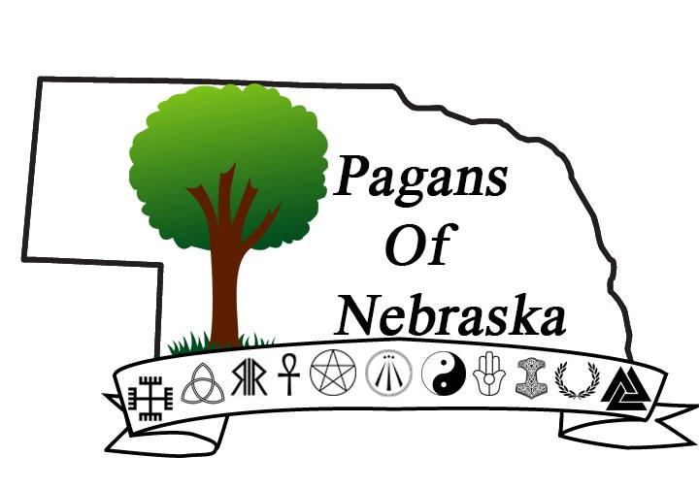
Welcome to the first ever Pagans of Nebraska Newsletter. The focus of Pagans of Nebraska has always been to further connect our community. Part of bringing our community together is learning from each other. This newsletter is an extension of that idea. I would like to thank all the contributors to this issue Eos, Taelon, Britteny, and Felina. All of the work and insight you have brought to this project is appreciated. I hope everyone enjoys this edition focused on the Fall/Samhain season. As always if there is anything you would like to see in upcoming issues message me on Facebook or my email.
Thank You All!
Aegan Wynn (Sarah Lee-Regier)
Mysticmama_77@yahoo.com
- The Wheel of the Year - Samhain
The wheel of the year is the four seasons broken into eight points. These eight points are measured by the two solstices and two equinoxes each year. The other four holidays or Sabbats are the stages between each of those four major solar events. Commonly each point tells the story of the god and goddess’ trials and his rebirth each year symbolizing life and death, and of course it’s reflected in the seasons. There are so many different folklore/pantheons that goes with each Sabbat that it’s up to you to find one to relate to.
Samhain or commonly known as Halloween is the first Sabbat or stop on the wheel of the year. In British Traditional Wicca Samhain is the witches’ New Year. Though, I have heard of some other traditions that start on the vernal equinox, or Ostara. They are not the common practice though. It is the witches’ New Year as this Sabbat symbolizes death. As without death there can be no rebirth. Another concept is that death is not the end, but actually the beginning. Because the leaves fall, the grass recedes, air becomes crisp, and void of pollen are just a few examples of why this time is associated with death. This is also the reason the “veil” is thin as Earth is in the stage of being barely alive. This makes reaching out to the spirits simpler for most than other parts of the year. Hence this is how modern twists have brought out the ghouls to get their sweets.
Besides the modern way of celebrating with candy, haunted houses, jack-o-lanterns, and costume parties there are many alternatives. One of the oldest traditions is leaving a white candle lit in a window to guide your ancestor’s home to visit, and rest. A personal favorite is simply being around friends, and family talking about the memories of loved ones who have left this realm for the next. This way they can be honored, and hopefully hear the happiness they’ve left behind. Though, whichever way you decide to celebrate this year I wish you a solemn Samhain.
~Eos

Friday, September 19, 2014

Mercury Retrograde of Autumn 2014: Shapeshifting Through the Shadows

Retrograde Shadow Begins 9-14-14 @ 4:02am CDT
Retrograde Begins 10-4-14 @ 12:02pm CDT
Retrograde Ends 10-25-14 @ 2:16pm CDT
Retrograde Release 11-10-14 @ 6:13am CST

The Shadow of the Mercury Retrograde

The Shadow period began on the morning of September 14th, when Mercury entered the part of Libra that it will be in again once it turns direct on October 25th. This time period, before the retrograde, is often when we are moving along full-speed ahead and missing a few important details in our journey. The main one likely happened on or around the day of September 17th, when Mercury exacted a conjunction with the North Lunar Node, and someone influential likely had a message for you that could help you advance your plans. Whether or not you were paying attention then, the opportunity (or another like it) may arise once more on October 29th when the same aspect happens after Mercury is in direct motion again, and we are retracing our steps in the final shadow period. Aside from the nodal conjunction and a few fleeting aspects with the Moon, most of Mercury’s relationships to other celestial bodies throughout the initial shadow period indicate quite a bit of mental stress and/or exhaustion. Of course, other great things are happening, or have the potential to happen, in the midst of this mental frenzy…but are we all-there enough to notice and take advantage of opportunities that arise?

Rain Check!

After a few weeks of overstimulation and mental congestion, Mercury in Scorpio detects an underlying issue: we’ve been ignoring our intuitive sense, thinking we’re being more productive without the clouds of confusion that it sometimes brings before answers are clear…or maybe we’ve just been dumbing it down with other things altogether. So, Mercury holds everything momentarily (when it stations retrograde) and gives Neptune Retrograde in Pisces, his psychic friend, a call to set up a meeting. “You have to go back and look at things from a different perspective before you can understand, and benefit from, the near future. Meet up with me on the night of 11-11, after you’ve taken your time inward and gotten back on track. What almost is now, will be by then.”

And cryptic as Neptune often is, Mercury already senses the need for this shift. Accordingly, he begins an inward journey through what already was and dares to find some hidden truths previously overlooked. The day this shift occurs (the exact shift is at 12:02 pm CDT on October 4th), the global mindset is a bit shaky. We were just in the middle of things that needed some focus and logical communication to accomplish…and now what’s happening? Delays, confusion, transportation issues, scheduling snafus, and Murphy’s Law in full effect? Sure, that can happen as Mercury stations retrograde, but is that what it’s all about? Absolutely not. And, does irritation in the daily grind have to be your experience of this time? Not even close. It’s all about perspective.

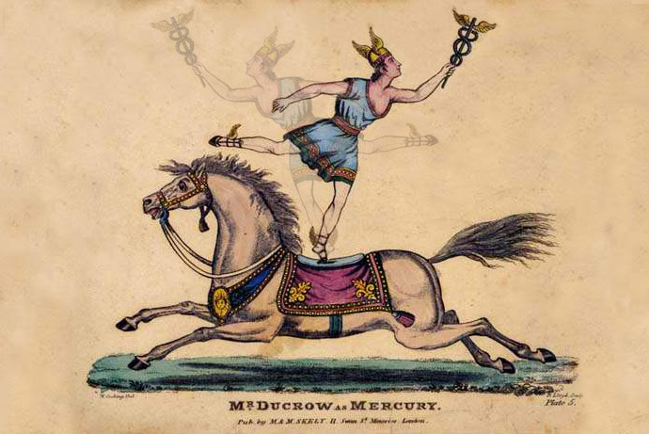
The Retrograde Station (in effect from 12:02pm CDT on October 3rd to 12:02pm CDT October 5th) is the big slowdown, when the ordinary activity of the mind—as well as the ordinary conduct of business and commerce—sometimes seems to have stopped in its tracks, unwilling to continue its course. Once Mercury begins moving in retrograde, though, our minds begin to turn toward vistas of knowledge and wisdom that call us from a distant past beyond our present lifetime. And since Mercury retrograde periods often have topsy-turvy inclinations on our minds and communications…rational intellect may be replaced with gut instinct as logic gives way to intuition. However, during a Mercury retrograde, our actual ability to think and communicate doesn’t slip into reverse—it is our perceptions, assumptions, and projections that turn things around. After all, the trickster planet in its orbit stays on a steady course; it never actually goes backward. It is only from our perspective on Earth that we see Mercury (or any planet in retrograde) appearing to reverse its course.

On the morning of October 5th, the past comes calling briefly…likely while you are still sleeping…with a lunar trine to Mercury. But during the station, not much else arises as a harmonious opportunity besides those memories from the Pisces Moon and the echoes of that 11-11 trine to Neptune retrograde. The weekend may feel like one where your mind just checks out for a while…where either the exhaustion catches up with you, or you just take a weekend retreat to reconnect with your spiritual side. If you have other plans, don’t worry. What does come up or is already scheduled (providing plans aren’t canceled last minute), is likely a necessary starting point to this retrograde process. Embrace it and make the best of it, as it could prove to be exactly the thing that will open your mind to other perspectives.

Enter Mercury Rx, the Cure for What Ails Ya

I doubt I’m the only one who’s noticed that the Rx symbol for a retrograde is very similar to the symbol we use for a prescription. It seems appropriate to me though, considering that the initial shadow of the Mercury retrograde often presents us with the root of whatever ailment arises during its retrograde station. Throughout the duration of the retrograde then, Mercury (who has always been seen as somewhat of a shapeshifter for his associations with the gray area between polarities) becomes the shaman travelling through non-ordinary reality, retrieving scattered pieces of what we left behind in our recent past, in order to provide some holistic healing.

On the morning of October 8th, the Full Blood Moon (exact at 5:50am CDT) brings about many revelations…while the Lunar Eclipse (beginning at 5:55am CDT) brings our awareness to the shadows. Many of these insights will have to do with relationships of all kinds. However, our primary partnerships are specifically poised for healing as Mercury Retrograde makes a rare aspect pattern with Mars, Chiron Retrograde, and Juno while the Blood Moon in Aries conjuncts Uranus Retrograde and the South Lunar Node in the 7th House for some surprising insights into the shadows of our past connections. Many other aspect patterns surface at the full moon eclipse as well, so be sure to mark your calendar for an interesting week and pay attention to what surfaces. The full moon’s effect can be felt two days before and after the opposition of the luminaries is exact…and when there is an eclipse along with it, what surfaces from the shadows has implications that can last for 6 months afterwards.

On the morning of October 13th, Mercury Retrograde lines up with Pallas (the asteroid of the female warrior) to combine metal strength, strategy, the ability to understand patterns and the wisdom to use it together with Mercury’s retrograde quest to reconnect the pieces.

By October 16th, Mercury Retrograde enters into combustion with the Sun. On a chart, that means they are conjunct. In the sky, that means Mercury seems completely swallowed by the sun’s light and appears invisible. And symbolically, the combustion indicates that Mercury’s worldly significations are eclipsed, but its spiritual significations become even stronger. So there may be some awkwardness in the areas of your life that Mercury rules in your natal chart, but your spiritual intellect will be heightened during this time. Venus is conjunct in this Libra stellium as well, and by the next day, Mercury and Venus will exact their own conjunction while making a sextile to Mars….opportunities abound when the inner planets connect harmoniously, but you have to keep your eyes and mind open to find them. Your best bet is midday in a public place, either during lunch or at work.

Another series of beneficial opportunities presents itself the next week when Mercury Retrograde makes a sextile with Jupiter then conjuncts the North Lunar Node (afternoon and late evening on Oct. 20th). Both of these are extremely good indicators that fortunate opportunities can arise from contacts with helpful people. Then the Moon in her balsamic phase conjuncts with Mercury Retrograde (afternoon on Oct. 22) before the Solar Eclipse (beginning at 4:45pm CDT) and New Mourning Moon (exact at 4:55pm CDT) on October 23rd to make a 7th House Scorpio Stellium between Venus, Sun, Moon, and Pallas that will have lasting effects for another 6 months in the area of primary partnerships, once again. Are you sensing a recurring theme? After all, Mercury began this retrograde journey in Scorpio, but quickly made its way back to Libra, the sign of relationships, compromise and harmony. The focus is very much on the important people in our lives and our relationships with them as well as with ourselves.

Mercury as the Pathfinder

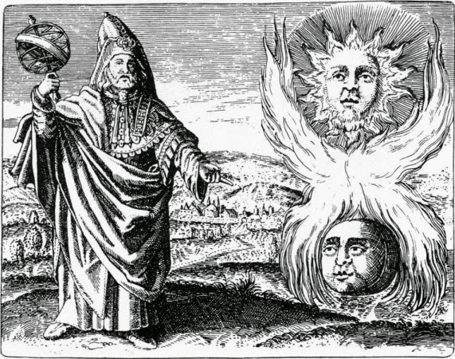
Mercury stations direct at 2:16pm CDT on October 25th (though the station goes on for 24 hours before and after that exact shift), just in time to back out of a Cardinal Grand Cross with Uranus Retrograde, Pluto, and Hygeia before things get too serious. The main goal now is to take some time out during this weekend, reflect on where your spiritual compass has directed you throughout this journey, and chart a new course through familiar, though newly understood, territory.

After an eye-opening sojourn through non-ordinary reality, Mercury returns to a calmer state of being. In this station, the mental state is restored and Mercury (along with those channeling him) can pass the knowledge and experiences of that retrograde on to others, helping them to successfully navigate life. Stability as well as the benefits associated with Mercury’s usual course are restored as the planet of communication moves forward again from our perspective.

Release from the Retrograde Shadow

Almost there! One last leg of this journey that is often overlooked is the final shadow period and eventual release. October will be a month of shadows, for sure. In this shadow period, we are retracing steps our minds have already covered forward and backward…but this third time, we’re ready for what’s coming (whatever it may be).

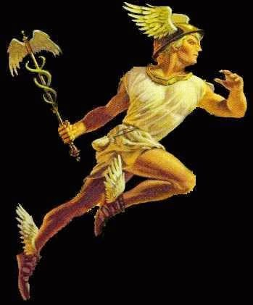
On October 29th, Mercury reconnects with the North Lunar Node which can, again, lead us to someone who has an important message for us and can connect us to future goals. Be sure to communicate those goals and best intentions for future plans on the night of Samhain, because Mercury and Jupiter return to a sextile (exact the following morning on Nov. 1st) and what you communicate will grow with abundance.

As far as the rest of the shadow period, much like the time-which-is-no-time after Samhain, Mercury makes no major aspects again until after the release (Nov. 10th @ 6:13am CST). The release is when Mercury makes it past the point of the zodiac where it first stationed retrograde…so at this point, we’re no longer re-tracing our steps and our minds can move on to new things.

Have a lovely autumn, an insightful Mercury retrograde, and a blessed Samhain!
Love and Gratitude,
Felina Lune Kavi

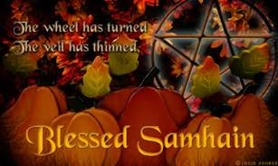
Samhain
Samhain, pronounced "sow-en", is often referred to by the bulk of society as Halloween. This holiday marks the end of summer and is the eve of the New Year. It is during this time that the veil between the spirit world and the physical world is at its weakest, meaning the barrier that separates is able to be breached with more ease than any other time of year. This is the time when it can also be the most dangerous. When contacting spirits during this time of year, one must be aware of a few things:
- Almost all knowledge regarding the affairs of any human walking this plane are known to all forms of spirit, those who have walked here before, and those who haven’t. When communicating with spirits from the other planes it is vital to ensure you’re speaking to the correct one(s). When it comes to family spirits, especially be cautious, as darker spirts relish the opportunity to entice a fleshing (human). There are obvious things that destruction is unable to understand. The meaning behind a nickname given via love or other creative emotion, while being able to be given to you, the reason behind it will remain only to that family member or others that it was shared with, other creative spirits. Before you get over excited that you’re speaking to whom or whatever, please verify that you have the intended one.
- Protecting oneself is always important, despite whom the intended is. The most advanced in dealing with spirits will tell you to always protect yourself when calling spirits in any form. Just because you intend for one to manifest doesn’t always result in such. The most common and effective ways to protect oneself are to be within a white salt circle and have some sage burning. Salt is the best protective and preventive method for darkness and destruction. The sage will ward off and prevent darkness and destruction from being able to access all of what they can. Most often than not, the area will just be avoided. This leaves creative spirits as the most probable option, as a spirit, to enter your dwelling.
- Lastly, use common sense. If something doesn’t “feel” right or you get a sense that something may go wrong, please trust this instinct. The mind is very amazing and the subconscious is very protective of itself. You will never cause yourself to be in a situation you are not comfortable in, willingly. Do not succumb to peer pressure or the need to fit in and participate in something you have “bad” or “harmful” thoughts, opinion, or feelings about. When during spiritual summons in general you want no negative energy to draw harmful spirits with. Trust your instincts, they will keep you always safe and protected as best they are able.
This particular time in general is a time when the mind is constantly active and curious. This heightens the subconscious part of the mind where knowledge and certainty are kept. This time of year can be a great awakening where the spirit within each of us can share knowledge of past experiences and future ones as well. Be open to the endless possibilities that life can take and share the experiences with others that each of you may grow and further yourselves. Blessed Be, Taelon

Sugar Skulls
This fun craft/activity is easy to do with kids and they can be involved in the entire process!
First items you will need to gather: 3 cups of sugar, 1 large egg white or 3 teaspoons of Meringue powder, (If you uses Meringue powder will need at least 3 teaspoons of water!), skull mold (there are many too choose from I got a cake pan that was skull shaped, there are some that you have the back and front half to put together. I purchased mine at Mangelson’s)
Icing items need: 1 large egg white, 1/8 teaspoon of cream of tartar, 1 ½ cups of powder sugar, food coloring
- Mix in a bowl, mix all the ingredients. Until you can press your thumb print into the mixture and it holds its shape.
- Scoop into mold. Gently packing it down. When full, make sure to take a flat blade and even out bake.
- Let air dry for about 12-24 hours.
- Hold plate against mold and flip over gentle tap to release skull.
- If using a mold with two halves, use icing to glue together. (Icing recipe below)
- Let dry about an hour to make sure it doesn’t crumble.
- Decorate!
This makes about 2 Medium size Sugar Skulls. In my pan I get about 4-6 skulls.
Icing:
- In a bowl, with a mixer on high speed, whip 1 large egg white and 1/8 teaspoon cream of tartar until foamy.
- Gradually beat in 1 1/2 cups..
- Add a few drops of food coloring and mix. I usually divide small amounts into sandwich baggies than add food coloring. You can also divide it into bowls.
- If necessary, beat in more powdered sugar to make icing stiff enough to hold its shape when squeezed through a pastry bag.
Makes about 3/4 cup, enough to join and decorate one or two skulls.
Can use feathers, beads, markers, icing pens, etc. It is all up to your and your families’ imagination. Than once icing is dry, use as a decoration around the house or on your altar.
Britteny Landon
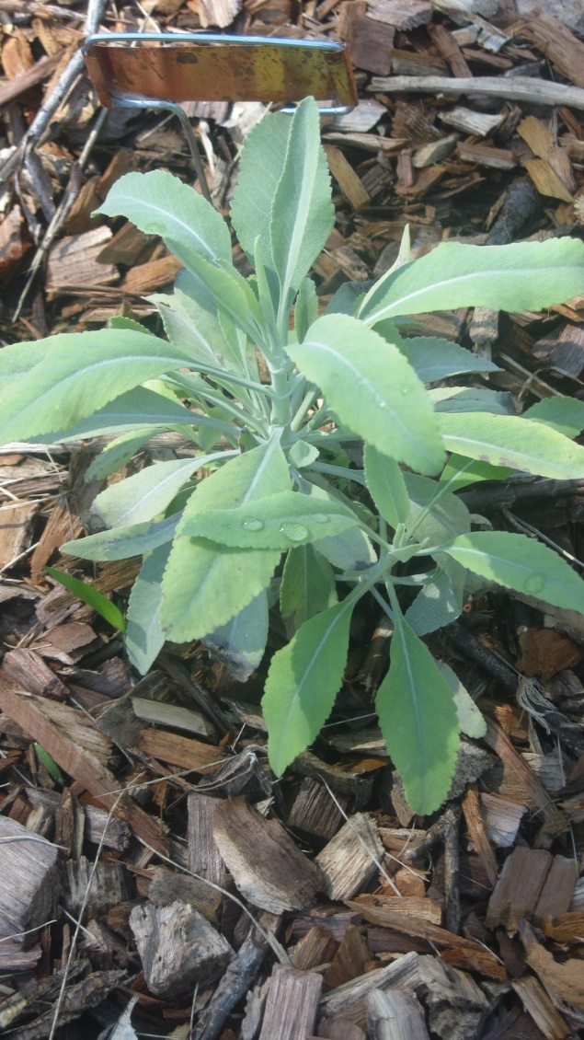

White Sage Salvia apiana
From Family: Lamiacreae
Other names: Bee Sage, California White Sage, Salvarial
Gender: masculine
Element: Air
Planet Association: Venus, Jupiter
God/dess: Cadmus (Greek), Consus (Roman), Jupiter (Roman), Zeus (Greek)
Astrological sign: Leo
Useable parts: leaves, stem, seeds
Edible parts: stems, seeds, leaves
Magickal Uses: Spiritual purification, protection, heal, cleanse, immortality, longevity, wisdom, granting wishes, used in many healing and money spells
• Believed to help alleviate sorrow of the death of a love one
• Wish: Write wish on leaf of sage, sleep on it for 3 days, than bury
• Add sage to mojo bags to promote wisdom and to overcome grief
• Said when smoked induces sacred dreams due to the calming effects of smoke & good spirits it attracts
Medical Uses: relief of stomach aches, tooth aches, colds, flu, asthma, promotes menstruation, cleanse skin wounds and rashes, blood tonic, coughs, and has been used as eye cleanser
• Suck a leaf or drink water with a leaf in it is useful for sore throats
• Recommended no more than 1 leaf per cup of water
• Should not be ingested by women who are pregnant!!!!!!
• Leaves exhibit some anti-bacterial action
• Smoking sage is said to help people recovering from addiction
Edible uses: condiments, spice, drink, Pinole
• Seeds main ingredient in Pinole- seeds are grounded and mixed with flour
• Leaves used in teas
• Said one should suck on a leaf or drink sage in water (1leaf/cup) everyday to strength the soul, remain calm, peaceful, and healthy
Other uses: incense, been used in hair shampoo, dye, hair straightener, poultice applied to armpits to treat body odors
Extra Information: Many white aromatic plants from SW U.S. that are called smudging sages are in fact Artemisias species.
• Difficult to grow in captivity, largely wild crafted (gathered from wild sources) which commercial demand threatens wild populations
• Any of Salvia species can be used to smudge
• Part of mint family
Sources:
• Sensualanimist.com/2012/03/16/292/
• www.witchipedia.com/herb:sage
• www.mountainroseherbs.com/products/ceremonial/-sage/profile
• Companionplants.com
• www.pfaf.org/user/Plant.aspx?LatinName=Salvia+apiana
• Cunningham’s Encyclopedia of Magical Herbs by Scott Cunningham
• A compendium of Herbal Magick by Paul Beyerl
• Hoodoo Herb and Root Magic by Catherine Yronwode

Spiral Scouts
We are almost done with chartering our circle. We are hoping to have all finished by the end of the month (fingers crossed for no hiccups). We plan on having meeting to finish organization items on October 12th and 26th at 2 p.m. at Next Millennium. These are subject to change. It is a $20 registration fee for children to become a scout and $20 registration fee and $10 background check for those adults who would like to volunteer. If you would like to sign up, contact Eric or Britteny Landon for more details.

October
Sunday | Monday | Tuesday | Wednesday | Thursday | Friday | Saturday
 |  |  | 1 | 2 | 3 | 4  7pm- S.G.
5  12-8pm  Conjure fest | 6  Full Moon | 7 | 8 | 9 | 10 | 11
12  2pm- S.S. | 13 | 14 | 15 | 16 | 17 | 18  7pm- S.G.
19 | 20 | 21 | 22 | 23  New Moon | 24 | 25
26  2pm- S.S. | 27 | 28 | 29 | 30 | 31  Samhain

Legend
10/4- Study Group on Spirit Animals at the Next Millenium (just North of 93rd and Maple)
10/5- Conjure Fest at the Conjure Shop 809 ½ South 75th Street (just north of 75th and Pacific)
10/12- Spiral Scouts meeting at the Next Millenium (just North of 93rd and Maple)
10/18- Study Group on Samhain at the Next Millenium (just North of 93rd and Maple)
10/26- Sprial Scouts meeting at the Next Millenium (just North of 93rd and Maple)

November
Sunday | Monday | Tuesday | Wednesday | Thursday | Friday | Saturday
1
1pm- Ritual
2  Daylight Savings Time Ends | 3 | 4 | 5 | 6  Full Moon | 7 | 8
9  2pm- S.S. | 10 | 11 | 12 | 13 | 14 | 15  7pm- S.G.
16 | 17 | 18 | 19 | 20 | 21 | 22  New Moon
23  2pm- S.S. | 24 | 25 | 26 | 27  Thanksgiving | 28 | 29  7pm- S.G.
30 | 31

Legend
11/1- Samhain Ritual at the Next Millenium (just North of 93rd and Maple)
11/2- Daylight Savings Time Back one hour
11/9- Spiral Scouts meeting at the Next Millenium (just North of 93rd and Maple)
11/15- Study Group on Runes at the Next Millenium (just North of 93rd and Maple)
11/23-Spiral Scouts meeting at the Next Millenium (just north of 93rd and Maple)
11/29-Study Group on Meditation at the Next Millenium (justNnorth of 93rd and Maple)

